

Biomechanical Assessment with Video Gait Analysis


Biomechanical /Posture Assessment with Gait Analysis

What is a biomechanical assessment?

Biomechanics is the study of the movement of the bones, joints and muscles and how they affect our walking, running and standing posture. The assessment is carried out by our Health and Care Professions Council (HCPC) registered podiatrist who specialises in postural aches, pains and injuries. The assessment can be complemented by state-of-the art high speed video gait analysis, which involves filming the whole of the body in slow motion from the front, side and back.

Why would I have a biomechanical assessment?

Most people have a biomechanical assessment because they are experiencing pain within the lower limb. This pain can be anywhere from the back down into the feet. You do not have to have a specific sports injury, it may just be pain which is present when walking or doing a specific movement. Occasionally, people attend for biomechanical assessment in an attempt to improve posture or prevent/reduce the risk of injury.

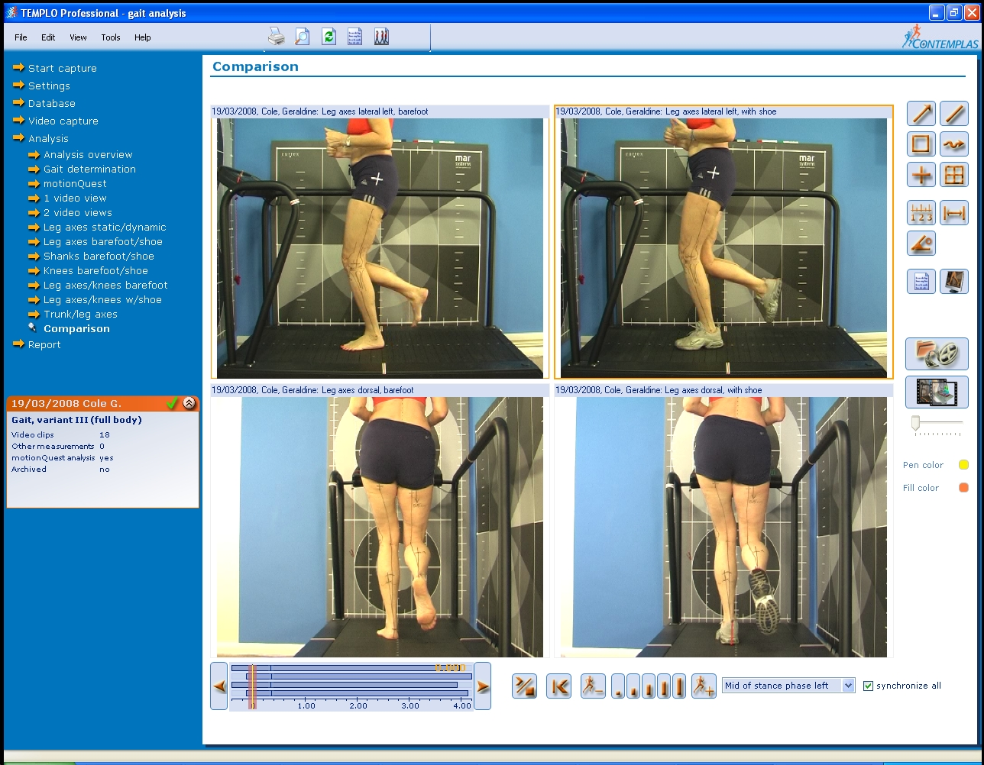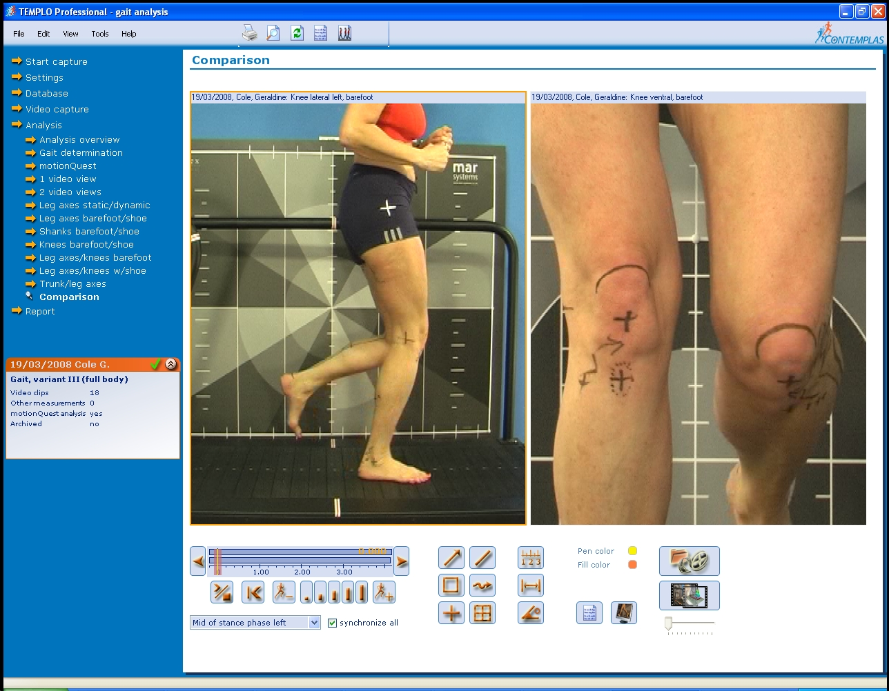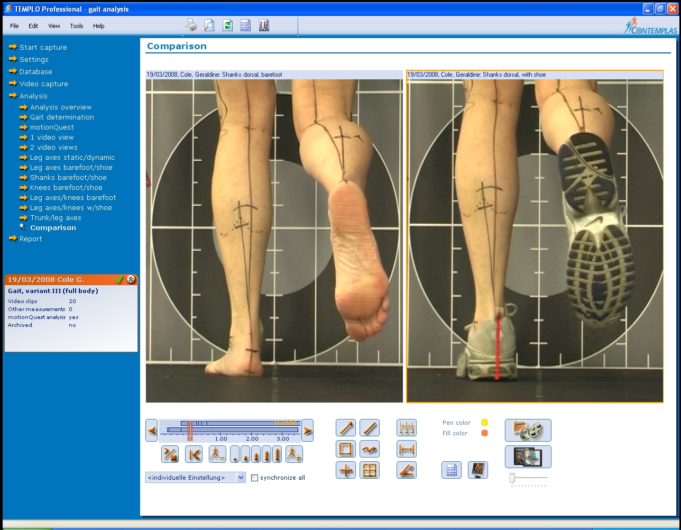

General conditions commonly treated include:-

Foot and heel pain, plantar fasciitis, ankle pain, shin splints, calf pain, hip pain, knee pain, Iliotibial band syndrome, buttock pain, lower back pain, postural problems, flat feet and leg length differences.

What is the price of the biomechanical assessment?

At Feet in Focus we offer different levels of assessment:

- Standard Biomechanical Assessment (gait analysis of foot only) 60 minutes / £120
For problems below the knee such as shin splints, foot and ankle pain

- Premium biomechanical assessment with gait analysis of full body 1.5 hours / £175
For problems affecting the knee, hips and back or more complex problems

- Consultation with our podiatrist 30 minutes / £50
Gait analysis not included but may be required at a later date

- Review appointment following biomechanical assessment 30 minutes/ £40-50

If you are not sure whether you need a full biomechanical assessment, you are welcome to book in for a consultation with our podiatrist who will conduct a shorter consultation and advise on appropriate treatment plan, this may include a recommendation to book a biomechanical assessment.

What type of assessment is most suitable for me?

The basic biomechanical assessment is ideal for all individuals of any age who are keen to find out the cause of any postural pain, such as foot, knee, hip or back pain.

The premium biomechanical assessment is a more comprehensive assessment and allows our podiatrist to analyse the whole body in motion and identify simple - as well as more complex - issues that may not been seen in our basic assessment. It is well suited to all individuals who want to get to the bottom of any aches and pains and includes casual walkers, sports enthusiasts of all levels as well as athletes.

Many people who engage in sports also benefit from having a biomechanical assessment to identify any muscle weakness/ tightness and to keep injury free.

What does the assessment involve?

A full medical history should be recorded, specifically taking details of the injury or site of pain. It is also important for the podiatrist to know about any previous accidents, fractures and surgery.
A static standing assessment will look at your relaxed posture and alignment. A couch examination will involve analysis of the hips, knees, ankles and the joints in your feet including the muscles. The podiatrist will be looking at the range and quality of movement available comparing this to the opposing limb as well as to what we know to be normal for the general population.

Patients undergoing the assessment will be marked up on specific body parts such as knees, feet, back and hips and will be asked to walk and sometimes run on our specialised Sprintex gait analysis treadmill barefooted and in shoes/ trainers. Compared to traditional gym treadmills, with a single belt which propels the body forward unnaturally, the Sprintex model has separate slats which recreate the natural motion of walking and running. And because it can work in reverse, you can be filmed both from the front and back, as well as from the side.
The information obtained in the biomechanical assessment will be analysed by our podiatrist who will explain the likely cause of your injury and will then outline an evidence based treatment plan based on the findings of your assessment.
Treatments commonly include the following:

- Stretching and strengthening exercises.
- Specific trainer recommendations.
- Mobilisation techniques
- Dry needling (acupuncture) and Steroid injections for pain relief and reduction of inflammation.
- Off-the-shelf orthotics (orthoses is a termed used to describe a foot or shoe insoles/support).
- Prescription / custom made orthotics.
- Further investigations including x-rays, diagnostic ultra-sound, MRI.

If you wish to book a biomechanical assessment with our highly skilled podiatrists please call (02920) 644 900 and book our 60 minute basic assessment or our 90 minute premium assessment. If you have any specific questions please call the clinic and our friendly receptionists should be able to talk you through our biomechanical assessment services or email info@feetinfocus.com

